1. **Write a C program to implement Array operations such as Insert, Delete and Display.**

**PROGRAM:**

#include <stdio.h>

#define MAX_SIZE 100

void display(int arr[], int size) {

printf("Array elements: ");

for (int i = 0; i < size; i++) {

printf("%d ", arr[i]);}

printf("\n");}

int insert(int arr[], int size, int element, int position) {

if (size >= MAX_SIZE) {

printf("Array is full. Insertion not possible.\n");

return size;}

for (int i = size - 1; i >= position; i--) {

arr[i + 1] = arr[i];}

arr[position] = element;

return size + 1;}

int delete(int arr[], int size, int position) {

if (size <= 0) {

printf("Array is empty. Deletion not possible.\n");

return size;}

for (int i = position; i < size - 1; i++) {

arr[i] = arr[i + 1];}

return size - 1;}

int main() {

int arr[MAX_SIZE] = {1, 2, 3, 4, 5};

int size = 5;

display(arr, size);

size = insert(arr, size, 10, 2);

display(arr, size);

size = delete(arr, size, 3);

display(arr, size);

return 0;}

**INPUT:**

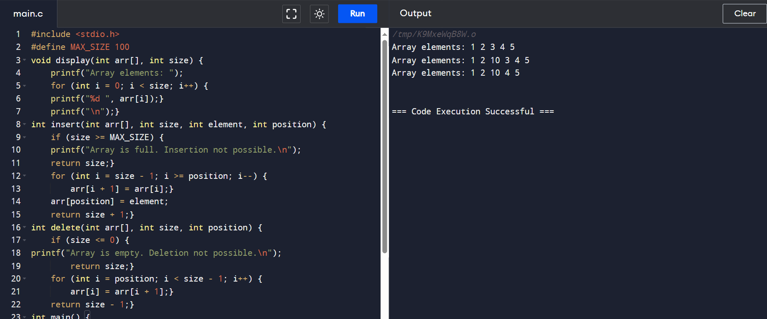

**OUTPUT:**

